C0801001051

数据结构与算法

实 验 指 导 书

东北大学软件学院
2019年9月
目 录
前 言 3
实验要求 4
Experiment 1 Linked List（4 hours） 5
Experiment 2 Printer Simulation: FIFO（4 hours） 7
Experiment 3 Calculating "The Sum of Its Parts"（4 hours） 10
Experiment 4 Europe by Rail（4 hours） 14
《数据结构与算法》实验报告 18

前 言
《数据结构与算法》是软件工程专业的核心课程。这门课程的目的和任务是通过学习使学生全面掌握各种常用的数据结构、存储结构及相关算法，为今后学习专业课及继续深造奠定基础，为提高利用计算机解决实际问题的能力创造条件。
要求掌握线性表、栈、队列、树、图及散列等常用的一些数据结构的逻辑形式、存储形式以及实现各种操作的算法。掌握在上述各种数据结构上经常实现的查找和排序的基本方法。能对工作中遇到的一些算法的时间复杂性和空间复杂性进行分析。能根据用户的要求及系统提供的数据，设计或选择合适的数据结构并能编写正确的算法。
通过本课程的实验，使学生加深对课程内容的理解，培养将原理应用于实际的能力，提高软件设计、算法应用、编程及调试的综合素质。学院提供了良好的教学实验环境。希望同学们能够充分利用实验条件，认真完成实验，从实验中得到应有的锻炼和培养。
希望同学们在使用本实验指导书及进行实验的过程中，能够帮助我们不断地发现问题，并提出建议，使《数据结构与算法》课程成为对大家有益的课程。

实验要求

《数据结构与算法》课程实验的目的是为了使学生在课堂学习的同时，通过一系列的实验，使学生加深理解和更好地掌握《数据结构与算法》课程教学大纲要求的内容。
在《数据结构与算法》的课程实验过程中，要求学生做到：
（1）预习实验指导书有关部分，认真做好实验内容的准备，就实验可能出现的情况提前做出思考和分析。
（2）仔细观察调试程序过程中出现的各种问题，记录主要问题，做出必要说明和分析。
（3）认真书写实验报告。实验报告模板见附录1。
（4）遵守机房纪律，服从辅导教师指挥，爱护实验设备。
（5）实验课程不迟到。如有事不能出席，所缺实验一般不补。
（6）本实验采用的开发环境为Eclipse，同学在做实验之前要求熟悉该软件的使用方法。
实验的验收将分为两个部分。第一部分是上机操作，包括设计结果的验收与检查。第二部分是提交书面的实验报告。

Experiment 1 Linked List（4 hours）
Prerequisites: Students should have mastered the following prerequisite skills.
- Linked Lists - Understanding of a linked list implementation
Goals: This assignment is designed to reinforce the student's understanding of linked lists.
Outcomes: Students successfully completing this assignment would master the following outcomes.
- Understand implementation of linked lists

Description
This assignment tests your understanding of linked lists and your ability to implement a linked list. Your job is to create an linked list that contains find and remove functionality.

Tasks
To complete this assessment, you need to declare and implement class LinkedList.
To begin, verify the files needed for this assessment.
Following is an ordered list of steps that serves as a guide to completing this assessment. Work and test incrementally. Save often
- First, declare your class LinkedList. It should be a generic class. It should have all the functions mentioned in the slides.
- Next, implement member function find_first. Use the following prototype to declare this member function:
T find_first (T key);
Method find_first should search the LinkedList for the first occurrence of an item that matches the value in the parameter key. It should return a reference to the first matching item. If the invoking LinkedList object is empty or no item is found that matches the parameter, a ListItemNotFoundException should be thrown.
- Then, implement member function find_all. Use the following prototype to declare this member function:
LinkedList find_all (T key);
Method find_all should search the invoking LinkedList for all elements that match the value in the parameter key. It should return an LinkedList object containing copies of all the items that match the parameter key. If the invoking LinkedList object is empty or no item is found that matches the parameter, this function should return an empty LinkedList.
- Next, implement member function remove_first. Use the following prototype to declare this member function:
void remove_first (T key);
Method remove_first should remove the first element from the invoking LinkedList whose data item matches the parameter key. If the invoking LinkedList object is empty or no item is found that matches the parameter, this function should do nothing.
- Finally, implement member function remove_all. Use the following prototype to declare this member function:
void remove_all (T key);
Method remove_all should remove all elements from the invoking LinkedList whose data items match the parameter key. If the invoking LinkedList object is empty or no item is found that matches the parameter, this function should do nothing.

Submission
Submit all the codes you need to complete.

Experiment 2 Printer Simulation: FIFO（4 hours）
Prerequisites: Students should have mastered the following prerequisite skills.
- Inheritance - Declaring and defining derived classes
- Queues - Programming queue structure
Goals: This assignment is designed to reinforce the student's understanding of queues.
Outcomes: Students successfully completing this assignment would master the following outcomes.
- Program a queue data structure and use it in creating a simulation
- Use inheritance appropriately to create a specialized version of an existing class

Background
From store-and-forward queues in network routers to the facilitation of breadth-first searches in graph algorithms, queues have many important applications in Computer Science and Information Technology. One such application can be found in a policy used by networked printers to manage print jobs. A complicated policy involves the prioritization of jobs that come from certain users. A simpler approach is a first-in-first-out policy. This policy dictates that print jobs are processed in the order they are received. A queue is used to implement this first-in-first-out policy.

Description
This assignment tests your understanding of queues and your ability to program a queue structure. The program you are asked to finish the implementation of simulates a shared printer. This printer uses a first-in-first-out queue.
The simulation works by reading and processing a list of events from a data file. Each line in a valid data file contains information about a print job and a time when this job was submitted. Specifically, the information contained in each line is the time (in seconds) the job was submitted, the length in pages of the job, and the name of the computer from which the job was submitted. At the beginning of the simulation, each of these events should be read in by the program and stored in the inherited workload queue.
The program should simulate the passage of time by incrementing a counter inside a for-loop or while-loop. The program should initialize this counter to zero and increment it by one second. A print job "arrives" when the current time of the simulation equals the submitted time of the print job at the front of the workload queue. When this happens, pop this event from the workload queue and place it in another Queue<event> object. This other Queue<event> object stores the "arrived" print jobs. These jobs wait in this queue while the program simulates the printing of other jobs. Hence, you may want to name this object waiting or something similar.

Files
Following is a list of files needed to complete this assessment.
arbitrary.run - Data file containing arbitrary print jobs
arbitrary.out - Output from a sample solution when run using arbitrary.run
bigfirst.run - Data file containing larger jobs first
bigfirst.out - Output from a sample solution when run using bigfirst.run

Tasks
To complete this assessment, you need to declare and implement the following classes.
To begin, verify the files needed for this assessment.
Extract the archive to retrieve the files needed to complete this assessment.
Following is an ordered list of steps that serves as a guide to completing this assessment. Work and test incrementally. Save often.
(1) Write your Queue structure class.
(2) Write the class Job, which represents a printing job and should have the following 2 data members: "string user" and "int number_of_pages".
(3) Write the class Event, which represents a submitted printing event and should have the following 2 data members: "job j" and "int arrival_time".
(4) Write the class Simulator to simulate a networked printer. It should have the following 2 data members: "int seconds_per_page" and "Queue<Event> workload". seconds_per_page data member determines how long a print job takes to print. This class should provide a member function "loadWorkLoad" to load the printing event data from corresponding files.
(5) Write a class Fifo which is a subclass of Simulator appropriately to model the following relationship: a fifo is a type of simulator. Next, define a method "simulate" to implement the simulation as described above. Your solution's output should match the output from the sample solutions.
For clarity, the word "latency" in the output file is the number of seconds that elapse between when a print job arrives and when it begins printing. Aggregate latency is the total latency of all print jobs, and mean latency is the average latency across all print jobs.

Submission
Submit all the codes you need to complete.

Experiment 3 Calculating "The Sum of Its Parts"（4 hours）
Prerequisites: Students should have mastered the following prerequisite skills.
- Trees - Knowledge of tree representation, particularly general hierarchies
- map container - Knowledge of use of map container, including iteration
- Recursion - Knowledge of creating a recursive solution for a problem
Goals: This assignment is designed to reinforce your understanding of trees and use of a tree.
Outcomes: Students successfully completing this assignment would master the following outcomes.
- Understand tree representation
- Use of the map container
- Produce a recursive algorithm to traverse a tree representation

Background
"The whole is greater than the sum of its parts" is a central theme of Gestalt psychology, and for humans it may be a true observation. Computers are much more literal-minded.

Description
In this assessment, you will construct a representation of a complex structure, a hospital that is composed of many parts. There are too many parts for a human to keep track of, which is why we want the computer to do it for us. The description of the hospital is contained in the file definitions.txt.
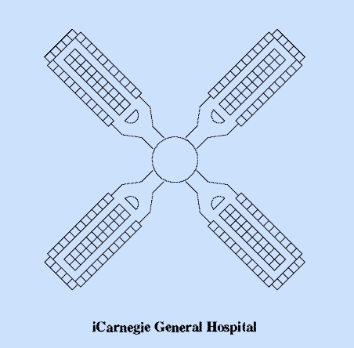
Figure 1 Layout of a floor in the hospital
The building has ten floors. Each floor has four wings emanating from a central core.
Each wing contains two long corridors joined at the end by a short connecting corridor.
Each long corridor contains twenty-one patient rooms. Each connecting corridor contains five supply rooms.
The hospital is described by a labeled tree, whose nodes are of type Part. A node contains children nodes corresponding to its subparts, as shown in the figure below. Each edge is labeled by the number of subparts the node contains. For example, the label 10 on the edge from hospital to floor indicates that the hospital has ten floors. You can assume there are no duplicate edges, that is, there is at most one edge between any two nodes.
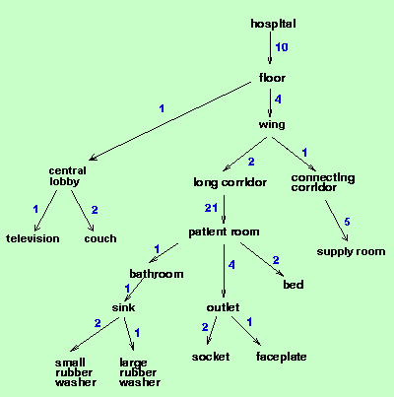
Figure 2 Tree representation of the hospital
The program first loads the file definitions.txt, which contains the subpart relationships that define the hospital. It then processes queries from the file queries.txt, which contains two kinds of queries about the hospital. The whatis query requests the description of a Part. The howmany query is the heart of the exercise. It asks how many instances of a Part are contained in another Part.
The steps below point the way toward a solution, but they do not cover every detail, so if you find you need to create additional functions or member items, feel free to do so.

Files
Following is a list of files needed to complete this assessment.
  - definitions.txt - Definition of part and subpart relationships
  - queries.txt - File containing queries to test your implementation.

Tasks
To complete this assessment, you need to complete the implementation of class Part and other helper functions.
To begin, verify the files needed for this assessment.
- Begin by implementing class Part. It should have a member named subparts that is a container of type map. Your container should map a reference (of type Part) to an integer. So, for example, the Part named hospital will have among its subparts an entry mapping a reference to the Part named floor to the int 10, since a hospital contains 10 floors.
- Next, implement the describe method of class Part. It should list the part name and all of the subparts and their quantities. Use iterators to process the subparts. Here are some examples of how output of describe should look:
- Part long_corridor subparts are:
- 21 patient_room

- Part floor subparts are:
- 4 wing
- 1 central_lobby

- Part couch subparts are:
- It has no subparts.

- Then, implement the recursive method count_howmany(Part p) of class Part that counts the number of instances of the part pointed to by p that occur in the invoking object. Counting proceeds by simple recursion on the subparts. For example, asking hospital how many wing subparts it contains, we see a hospital has 10 floors. Recursively asking floor how many wing subparts it contains, we see that a floor has four wings. Calling the recursive function again, we ask wing how many times it occurs in wing. The function returns the value 1 since this is the base case. The final answer is then 40 (10 * 4 * 1).
- Next, complete the implementation of method lookup of class NameContainer, which maps a string to a pointer to an instance of type Part. Method lookup should automatically create an instance of class Part with the given name if one does not already exist in the map. The method should return a pointer to the instance.
- Finally, write the helper function add_part(string x, int quantity, string y) that adds the part named y as a new subpart of the Part named x.

Submission
Submit all the codes you need to complete.

Experiment 4 Europe by Rail（4 hours）
Prerequisites: Students should have mastered the following prerequisite skills.
- Graphs - Knowledge of graph representation, particularly adjacency lists
- Graph Algorithms - Knowledge of Dijkstra's shortest path algorithm
Goals: This assignment is designed to reinforce the student's understanding of the implementation of a fundamental graph algorithm
Outcomes: Students successfully completing this assignment would master the following outcomes.
- Understand graph representation
- Understand how to implement Dijkstra's shortest path algorithm

Background
Traveling through Europe by rail is a cheap and effective way to experience the sights, sounds, and culture of a wide array of countries and cities. Generally, travelers purchase rail passes that allow unlimited travel on the rail system. Individual tickets, however, can be purchased.

Description
The program for this assessment calculates the cheapest route between two cities in a mock European rail system. The graph that represents the rail system is pictured below.
In this program, a weighted graph is constructed to represent rail services to and from European cities. Each service from a city has an associated destination city, a fee (in Euros), and a distance (in kilometers). The program processes user input of a source city and a destination city. The program then displays the cheapest route from the source city to the destination city. In addition, for each route, the total cost and total distance are displayed. The file services.txt contains the data for the available services.

Classes
This program should utilize three main classes, class City, class Service, and class RailSystem. Class City maintains information about a city. Class Service models a rail service from the rail system. This class contains public data members for a destination city, a fee, and a distance. Both of these classes are used by class RailSystem.
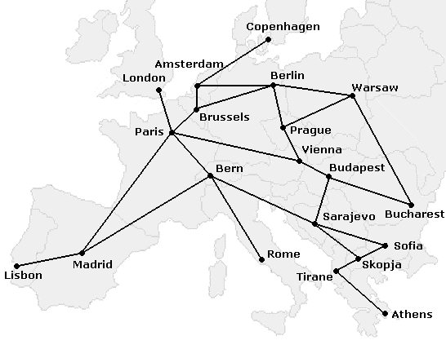
Figure 1 A mock European rail system
Class RailSystem models the rail system using an adjacency list representation. The following image represents how a portion of the rail system is represented. Note that the ticket fees and distances are left out to simplify the picture.
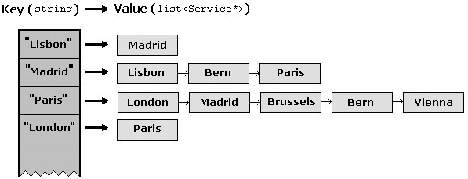Figure 2 Adjacency list representation of the rail system
Essentially, in the above representation, a linked list of outgoing services can be indexed using a string containing the source city name. For example, notice in the above picture, Madrid has three outgoing services: one to Lisbon, one to Bern, and one to Paris. This matches the picture of the rail system at the top of this handout.
Sample output from this program is shown in the figure below.
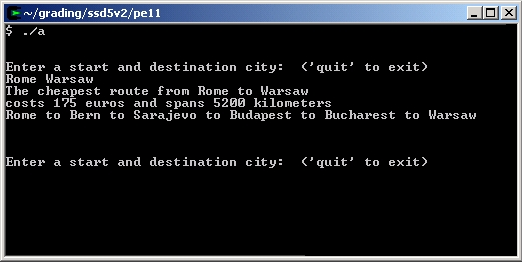
Figure 3 Output from a sample solution
The algorithm to be used is a positive-weighted, shortest path algorithm. Each City is a node in a graph, and each Service is an edge. Edges have an associated cost: the fee for the ticket. The goal is to find the cheapest route from the source city to the destination city.
To perform a new search, a reference to a Service object representing the start city should be added to an initially empty candidates queue. The algorithm continues by exploring the services of each candidate city, possibly adding new candidates to the list. The algorithm labels each City object with a number representing the cost of the cheapest route to it from the origin found so far. This can be stored in member total_fee of class City. This value may decrease as new routes that are cheaper are found, but the value never increases.
To recover the actual path found by the search, every City object contains a string from_city. This string will be updated by the search algorithm to contain the name of the city by which it was reached through the cheapest path. In other words, if examining Brussels reveals a cheaper path to Paris, update variable total_fee of the City object that corresponds to Paris, and set its from_city equal to "Brussels". Once the search is complete, the cheapest route to the destination has been found, and the from_city strings can be traversed from the destination to the origin to reconstruct the path.

Files
services.txt - This file contains data that defines the rail system services.

Tasks
To complete this assessment, you need to complete the implementation of a Graph data structure and the above mentioned classes.
To begin, verify the file needed for this assessment. Following is an ordered list of steps that serves as a guide to completing this assessment. Work and test incrementally. Save often.
Begin by completing the implementation of class City and Service.
Next, writing the class RailSystem and complete the member function load_services. The data file of services is services.txt. Function load_services() must correctly store the cities and outgoing_services.
Then, finish the implementation of function RailSystem::reset. This function should reset the data members of the City objects.
Next, complete the definition of function calc_route(). It should use a positive-weighted, shortest path algorithm.
Finally, implement function recover_route(). Function recover_route() accepts the name of a destination city as an argument, and returns a string which contains, in order, the city names from the source city from which the destination city was reached through the destination city. The path can be recovered through the from_city strings, which should have been set by function calc_route(). The city names must be separated by the four-character string " to ". See the screen shot of sample output above for samples of strings created by function recover_route().

Submission
Submit all the codes you need to complete.

课程编号：C0801001051

《数据结构与算法》实验报告



姓名 |  | 学号
班级 |  | 指导教师
实验名称 | 《数据结构与算法》综合实验开发与总结
开设学期 | 2019-2020学年 秋季学期
开设时间 | 第周——第周
报告日期
评定成绩 |  |  | 评定人
评定成绩 |  |  | 评定日期

东北大学软件学院

1. 实验目的
针对每次实验，写出你认为比较重要的实验目的

2. 实验内容与实验步骤

2.1 链表的实现
(1) 简短明确地写出实验的内容
(2) 简短描述抽象数据类型或设计的函数描述，说明为什么要使用这种抽象数据类型，并说明你的解决设想
(3) 简短明确地写出你实验所采用的存储结构及其用途，详细说明其中的属性的含义。

2.2 打印机模拟程序的内容与步骤
(1) 简短明确地写出实验的内容
(2) 简短描述抽象数据类型或设计的函数描述，说明为什么要使用这种抽象数据类型，并说明你的解决设想
(3) 简短明确地写出你实验所采用的存储结构及其用途，详细说明其中的属性的含义。

2.3 计算建筑内房间数
(1) 简短明确地写出实验的内容
(2) 简短描述你在实验中使用的数据结构及算法的基本原理。
(3) 描述你采用泛型中的什么容器或者类存储，在算法应用过程中使用什么数据结构或算法提高算法的效率。

2.4 欧洲旅行实验的内容与步骤
(1) 简短明确地写出实验的内容
(2) 简短描述你在实验中使用的数据结构及算法的基本原理。
(3) 描述你采用泛型中的什么容器或者类实现图的存储，在算法应用过程中使用什么数据结构或算法提高算法的效率。

3. 实验环境
操作系统、调试软件名称、版本号，上机地点，机器台号

4. 实验过程与分析

4.1 链表的实现
(1) 描述你在进行实现时，主要的函数或操作内部的主要算法，分析这个算法的时、空复杂度，并说明你设计的巧妙之处。
（2）你在调试过程中发现了怎样的问题？又做了怎样的改进？

4.2打印机模拟程序的过程分析
(1) 描述你在进行实现时，主要的函数或操作内部的主要算法，分析这个算法的时、空复杂度，并说明你设计的巧妙之处。
(2) 你在调试过程中发现了怎样的问题？又做了怎样的改进（要求写出具体的事例）
(3) 你的实现是

4.3 计算建筑内房间数
(1) 描述你在进行实现时，主要的函数或操作内部的主要算法，分析这个算法的时、空复杂度，并说明你设计的巧妙之处。
(2) 你在调试过程中发现了怎样的问题？又做了怎样的改进？
(3) 你的抽象数据类型的实现是否具有可扩展性？否具有可扩展性，如针对多个打印队列的仿真程序？

4.4欧洲旅行实验的过程分析
(1) 描述你在进行实现时，主要的函数或操作内部的主要算法，分析这个算法的时、空复杂度，并说明你设计的巧妙之处。
(2) 你在调试过程中发现了怎样的问题？又做了怎样的改进？
(3) 你的实验在解决类似问题时是否具有灵活的可修改性、可扩展性？

5.实验结果总结

5.1 链表的实现
回答以下问题：
（1） 你的测试充分吗？为什么？你是怎样考虑的？
（2） 你的存储结构的选取是不是很适合这个应用？为什么？
（3） 用一段简短的代码及说明论述你的应用中有关插入和删除元素是如何做的？
（4） 在你的应用中是否用到了头结点？你觉得使用头结点为你带来方便了吗？
（5） 源程序的大致的执行过程是怎样的？

5.2 打印机模拟程序的结果总结
回答以下问题：
(1) 你的测试充分吗？为什么？你是怎样考虑的？
(2) 为什么你要选用队列作为你应用的数据结构？
(3) 用一段简短的代码及说明论述你的应用中主要的函数的主要处理部分。
(4) 用结构化图表或者结构化代码描述源程序的大致的执行过程。

5.3 计算建筑内房间数
回答以下问题：
（1） 你的测试充分吗？为什么？你是怎样考虑的？
（2） 用一段简短的代码及说明论述你的应用中主要的函数的主要处理部分。
（3） 源程序的大致的执行过程是怎样的？

5.4欧洲旅行实验的的结果总结
回答以下问题：
(1) 你的测试充分吗？为什么？你是怎样考虑的？
(2) 在你的问题解决方案中，为图选取了顺序的还是链式的存储结构？为什么要选取这种存储结构？
(3) 用一段简短的代码及说明论述你的应用中主要的函数的主要处理部分。
(4) 在你的图中使用了怎么样数据结构来优化算法的性能？
(5) 源程序的大致的执行过程是怎样的？

6.附录
(1) 回答思考题
- 栈和队列在计算机系统中有哪些应用？写出你知道的系统中，这两种抽象数据类型的应用。
- 在程序调用的时侯，需要进行函数的切换，你认为函数在进行切换时系统要做那些工作？
- 队列在系统的设计中都起到什么样的作用？举出你所熟悉的一些队列的应用例子。
- 在你的四次实验中能使用Java中的哪些容器？各有什么用途？
- 假设一个图采用邻接表存储结构进行存储，在某一个结点的邻接结点链表中，结点的顺序是否会影响到最短路径算法的结果？
(2) 列出实验参考的资料
(3) 如果你对这两次实验还有其他的解决方案或设想，或对我们的实验方案有什么意见，请在此描述。

附录：

《数据结构与算法》实验成绩评定表


评价内容 | 具 体 要 求 | 分值 | 得分
平时表现 | 实验过程中，无缺勤现象，态度积极，具有严谨的学习态度和认真、踏实、一丝不苟的科学作风。 | 10
提交材料 | 能够按时规范提交实验要求的所有材料（要求在以“学号-姓名”命名的文件夹中，包含实验报告电子版、和分别以实验源代码一、二、三、四命名的存放两次实验源代码的两个子文件夹，源代码仅包含代码文件，不要包含工程维护文件等），材料完备，格式内容等符合要求。 | 10
报告质量 | 实验报告格式规范，体例符合要求；报告内容充实、正确，实验目的归纳合理到位，思考题回答准确。 | 30
实验内容 | 能够按实验要求合理设计并开发出程序，认真记录实验数据，原理及实验结果分析准确，归纳总结充分。 | 50
总 分

